Task 9 Database Check
  - Family Budget Tracker
Week 9 | Basics of Information Systems | Team database plan
This plan shows how a relational database can record a family expense and turn expense records into a monthly budget decision. Four connected tables separate members, categories, expenses, and monthly limits.

Team and proposed speaking roles
Student | Student ID | Proposed oral role
Kystaubekov Mukhamejan | 24B032166 | 1 Main action and tables
Sarsenbay Almas | 24B032028 | 2 Primary keys and data rules
Baitaliyev Dinmukhamed | 24B031677 | 3 Foreign keys and relationships
Mauken Bekzhan | 24B031914 | 4 ERD and repeated data
David Sebelev | 24B032010 | 5 SQL, decisions, security, transactions

Role assignments and improvement owners are proposed for team confirmation. The document does not establish that any student has already completed the proposed work. The oral cards include contribution prompts to complete truthfully after reviewing the design.

Main action
An authenticated family member adds an expense. The application identifies the member, collects a category, a positive amount in KZT, an expense date, and an optional note, validates the values, and saves one TRANSACTIONS row. The monthly report then reads the updated expense total.

Scope and business rules
This four-table checkpoint covers one household and expenses only. All money is in KZT. Each expense belongs to exactly one user and one category; each category may have one budget for each calendar month. A budget is optional for saving an expense, and exceeding a limit produces a warning rather than rejecting the expense.
Income, refunds, multiple households, receipt files, and authentication credentials are outside this checkpoint. A later multi-household design needs household membership and access isolation before use by unrelated families.

1 Database table plan
Design target: PostgreSQL. INT primary keys are database-generated identity values. PK means primary key; FK means foreign key; NN means NOT NULL. Every field is required unless explicitly marked nullable. FK columns use the same INT type as their parent keys.

USERS stores each member once
Field | Data type | Key and constraints
user_id | INT | PK, identity, NN; unique and stable
full_name | VARCHAR(100) | NN; trimmed value must not be empty
email | VARCHAR(254) | NN, UNIQUE; application trims and lowercases before save
role | VARCHAR(10) | NN; CHECK role IN ('admin', 'member')

Purpose: identify who recorded an expense and support access decisions. Names and emails may change without changing user_id. Email uniqueness does not make email the primary key. Basic email syntax is checked in the application.

CATEGORIES stores expense categories
Field | Data type | Key and constraints
category_id | INT | PK, identity, NN; unique and stable
category_name | VARCHAR(50) | NN, UNIQUE; nonblank; application normalizes whitespace and case
description | VARCHAR(200) | Nullable; explains intended use
is_active | BOOLEAN | NN; DEFAULT TRUE

Purpose: give expenses and budgets a shared category. This is an expense-only category list; no category_type field is needed. Deactivate categories instead of deleting those used in history. The application allows new expenses only in active categories.

Shared plan summary
Table | Purpose | Primary key | Foreign keys
USERS | Family member | user_id | None
CATEGORIES | Expense classification | category_id | None
TRANSACTIONS | One expense event | transaction_id | user_id; category_id
BUDGETS | Monthly category limit | budget_id | category_id

A foreign key is required in the connected design, not in every table. Parent tables USERS and CATEGORIES do not need an artificial FK.

2 Expense and budget fields

TRANSACTIONS stores individual expenses
Field | Data type | Key and constraints
transaction_id | INT | PK, identity, NN; unique and stable
user_id | INT | NN; FK references USERS(user_id)
category_id | INT | NN; FK references CATEGORIES(category_id)
amount | DECIMAL(12,2) | NN; CHECK amount > 0; application accepts at most 2 decimal places
transaction_date | DATE | NN; date of the expense, not the time it was entered
note | VARCHAR(200) | Nullable; avoid sensitive personal details

Purpose: record the main action. DECIMAL stores exact money values and avoids binary floating-point rounding. The authenticated account determines user_id; the application must not trust a user_id supplied by the client.

BUDGETS stores monthly limits
Field | Data type | Key and constraints
budget_id | INT | PK, identity, NN; unique and stable
category_id | INT | NN; FK references CATEGORIES(category_id)
month_start | DATE | NN; CHECK EXTRACT(DAY FROM month_start) = 1
monthly_limit | DECIMAL(12,2) | NN; CHECK monthly_limit > 0; at most 2 input decimal places

Table constraint: UNIQUE(category_id, month_start). A category cannot have two limits for the same month. A single month_start value avoids separate month and year fields that could contradict each other.

Integrity and validation
All three foreign keys use ON DELETE RESTRICT and ON UPDATE RESTRICT. A referenced user or category cannot be deleted while child records exist. Primary keys are not edited or reused. Invalid FK inserts are rejected by the database.
Example rules: reject amount = -500.00, amount = 0, a missing expense date, user_id = 999 when no such user exists, and a second budget for the same category and month. Optional notes and category descriptions may be NULL.
Client validation gives immediate feedback; server validation checks authorization and business rules; database PK, FK, NOT NULL, UNIQUE, and CHECK constraints protect stored records. These are proposed controls, not a claim that the application already enforces them.

3 ERD and normalization
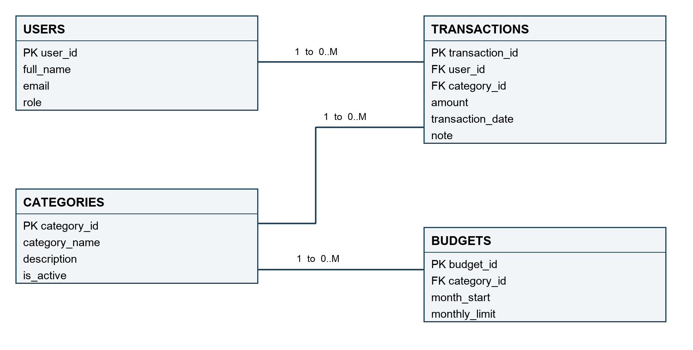
Figure 1. Each connector is a 1:M relationship. A parent can have zero or many children; every child has exactly one parent for each required FK.
Parent to child | Type | Meaning
USERS to TRANSACTIONS | 1:M | One member can record many expenses.
CATEGORIES to TRANSACTIONS | 1:M | One category can classify many expenses.
CATEGORIES to BUDGETS | 1:M | One category can have limits for many months.

No 1:1 relationship is needed. Users and categories have a conceptual M:N association through TRANSACTIONS: many users spend in many categories. TRANSACTIONS resolves it into two 1:M links and stores each expense event. Repeated user-category pairs are valid; do not make that pair unique.

One fact has one home
Names and emails live only in USERS; category names live only in CATEGORIES; monthly limits live only in BUDGETS. TRANSACTIONS stores references, not copies of these facts. A category rename updates one category row. Each field is atomic, and spending totals are calculated rather than stored, avoiding inconsistent cached totals.
Connected record example: TRANSACTIONS 101 uses user_id 1 and category_id 1. It points to demo user Alex and demo category Food. An absent user or category causes an FK error, not an orphan record.

4 SQL and a demonstrative result
Business question: Which individual expenses during October 2026 were greater than 10,000 KZT?
SQL
SELECT transaction_id,
amount,
transaction_date
FROM transactions
WHERE amount > 10000;
DEMONSTRATION ONLY. The rows below are invented teaching examples, not actual family spending or project results. All amounts are KZT. Demo USERS: 1 = Alex; 2 = Dana. Demo CATEGORIES: 1 = Food; 2 = Transport; 3 = Entertainment; 4 = Health.
Expense ID | User ID | Category ID | Date | Amount
101 | 1 | 1 | 2026-10-03 | 65,000.00
102 | 2 | 1 | 2026-10-10 | 45,000.00
103 | 1 | 2 | 2026-10-12 | 18,000.00
104 | 2 | 3 | 2026-10-14 | 10,000.00
105 | 1 | 3 | 2026-10-20 | 15,000.00
Demo RESULT: Filtering transaction records where amount is strictly greater than 10,000.00 KZT.
Transaction ID | Amount | Transaction Date
101 | 65,000.00 | 2026-10-03
102 | 45,000.00 | 2026-10-10
103 | 18,000.00 | 2026-10-12
105 | 15,000.00 | 2026-10-20
Data becomes information: Five individual transaction records are filtered down to four transactions exceeding 10,000.00 KZT. Expense ID 104 (10,000.00) is excluded because the query requires amounts strictly greater than 10,000.00. Proposed decision: Focus budget auditing on these higher-value transactions to identify primary spending drivers across all categories.

5 Access and transaction safety

Proposed access model
Only authenticated household members may use the application. For this one-household scope, members can see shared spending totals and category names, create their own expenses, and edit their own expenses. Admins can manage categories, monthly limits, and membership. Other users have no access.
Email addresses and transaction notes are sensitive. Members should see their own email and private notes; an admin sees contact details only for account administration. Shared reports omit emails and notes. Screens, endpoints, and database access must enforce the same policy. A role label alone does not enforce permissions.
The application server uses a restricted database account. End users do not receive direct database credentials. SQL uses parameters, with authorization checked on every request. Passwords are not stored in these four tables; authentication needs a separate secure component. Backup and restore tests remain proposed reliability work.

One atomic transaction
A member can optionally split a receipt into two expense rows, each with one category. Both rows represent one save operation. Example: Food 6,000 KZT and Transport 1,000 KZT. In this illustration, user 1 and categories 1 and 2 already exist.
BEGIN;
INSERT INTO transactions
(user_id, category_id, amount, transaction_date, note)
VALUES (1, 1, 6000.00, DATE '2026-10-21', 'Split receipt');
INSERT INTO transactions
(user_id, category_id, amount, transaction_date, note)
VALUES (1, 2, 1000.00, DATE '2026-10-21', 'Split receipt');
COMMIT;

This transaction example is separate from the five-row dataset on page 5 and is not included in that result. Identity columns generate the transaction IDs.
If the second INSERT fails, the application issues ROLLBACK and the first INSERT is undone. If both succeed, COMMIT saves both. The application must not report success before commit. The monthly total is read from committed rows; no stored balance needs a separate update.

Failure cases to demonstrate
Try a missing category in the second row: neither split row should persist. Try a zero or negative amount: CHECK rejects it. Try another member’s user_id: the server rejects the request before writing. A connection failure after commit can leave the client unsure of the outcome; safe retry and duplicate prevention are still future work.

6 Problem and improvement plan
Candidate problem to verify: a negative expense could reduce the spending total if validation is missing. This is a design risk, not a confirmed defect in the current application. First reproduce it in a test environment; if it is already prevented, record that evidence and select a real unresolved issue with the team.
Current problem or risk | Why it matters | Proposed solution
Negative or zero amount may be accepted if validation is absent. | Incorrect expense totals can hide overspending. | Check amount > 0 in the application and database; verify valid and invalid inputs.

Proposed responsible student | Next action and evidence | Proposed deadline
David Sebelev | Reproduce input behavior; record accepted/rejected cases and coordinate the fix. | Before the next project lesson; exact date to confirm.
Kystaubekov Mukhamejan | Review CHECK and NN rules; test −500, 0, 0.01, and NULL. | After reproduction and before the oral check.
Mauken Bekzhan | Verify all FKs and parent deletion restrictions. | Before the oral check.
Sarsenbay Almas | Compare the ERD with the agreed schema and confirm scope. | Before the oral check.
Baitaliyev Dinmukhamed | Run the SELECT on demo data; test rollback and review access rules. | Before the oral check.

Final team answer
Clear in this plan: the main action, four entities, keys, 1:M links, expense rules, and monthly report. Still to verify: the actual implementation, negative-input behavior, permission enforcement, rollback behavior, and duplicate-safe retries. The next action is to reproduce the amount-validation risk; David is the proposed coordinator, subject to team confirmation.

Assignment basis
The controlling brief is Week 9 Database Project.docx, especially “What your team must prepare,” “Every student must also say,” and “Marking policy 3 points.” Task 9 INFT3107.docx supplies the detailed role questions and speaking guidance; its older 2-point total is not used.
Week 9 Databases Interactive.pptx supports the design: slides 23–29 on keys and referential integrity; 30–38 on relationships and normalization; 42–49 on SELECT, transactions, and safe queries; 50–52 on permissions and the project checklist.
Assessment total: team work 1.50 points (tables and rules 0.40; keys 0.35; ERD 0.35; SQL and decision 0.40); individual work 1.50 points (oral explanation 0.60; contribution 0.40; problem and next action 0.50).

